# Media Analysis - Is the Arab world ready for the uncertain age of AI-powered web tools

## Short Summary

The article explores the advancements in AI, focusing on ChatGPT's text generation abilities, while acknowledging its limitations and the need for human oversight it also discusses AI's potential to enhance human capabilities and the importance of trust in its widespread adoption.

## Summary

The text discusses the current state and potential of Artificial Intelligence (AI), particularly focusing on large-language models like ChatGPT. These models, trained on vast amounts of internet data, can generate human-like text but lack understanding in a conventional sense. They are pattern-matching machines that produce content based on learned sequences from their training data.  
  
ChatGPT, an example of such a model, has shown capabilities in various areas like creative writing, problem-solving, and even passing university exams. However, its outputs should be treated with caution as they may not always be accurate or up-to-date, requiring fact-checking.  
  
The text also highlights the concerns surrounding AI's impact on professions such as journalism, education, and search engine usage. While there are worries about AI replacing human jobs, experts argue that AI is more likely to augment human capabilities rather than completely replace them. Human creativity, emotion, and personal perspective remain unique to humans and cannot be replicated by current AI models.  
  
The global market value of AI is projected to reach $11  
9.78 billion in 2022, with an estimated contribution of 1  
5.7 trillion to the global economy by 203  
0. The Middle East is expected to capture 2% of these benefits, equivalent to $320 billion.  
  
The text emphasizes the importance of trust and responsible use of AI. As AI continues to evolve, it will likely become more integrated into our lives, but it should always be used in conjunction with human intelligence and awareness. Experts are optimistic about AI's potential benefits while acknowledging the need for caution and ethical considerations in its development and deployment.

## Question 1:

How do the media (in our case = the sample we are analyzing) frame the public discussion about ChatGPT? Are there certain **metaphors** that keep cropping up?

1. **Machine as a Creativity Killer ** The text mentions that ChatGPT 'simpli es things' and is 'not able to replicate creativity, emotion, or personal perspective.' This metaphor frames AI as a potential threat to human creativity and original thought. It suggests that AI might diminish the value of human ingenuity by providing quick, pattern-based responses.

## Question 2:

Which role does the Arabic World play in the field of Artificial Intelligence in this article according to the author? Answer with 'Not mentioned' if not applicable.

Not mentioned

## Question 3:

How helpful is Artificial Intelligence for the Arabic world based on this article?

Based on this article, Artificial Intelligence appears to be highly beneficial for the Arabic world due to its projected global market value and potential to contribute to the region's economic growth. However, challenges such as trust, human intelligence, and ethical considerations must also be addressed for its safe and effective implementation.

## Question 4:

What is the final message of the article that the author wants to convey? Keep your answer short and precise!

AI's integration into society should be guided by human intelligence and trust, recognizing both its benefits and limitations.

## Sentiment

The sentiment is 0

## Entities

DeenSquare, Data Society, Generative Pre-Trained Transformer, Reid Ho, Microsoft, YouTube, Jenna Burrell, Arab News, Bing, Intelligence, Guardian, Noaman Sayed, ChatGPT, GPT, National Strategy for Data, AFP However, LinkedIn, Elon Musk, AFP Founded, Alex Hern, Peter Thiel, the Sciences Po school, Minnesota University Law School, UAE, James Webb, Omar Sultan Al-Olama, Alexa, Dan Milmo, Sam Altman, Museum of the Future, Google, AI, OpenAI, Nowson, LEAP, the World Economic Forum, Edge, Ahmed Belhoul Al-Falasi, Bard, Burrell, Scott Nowson

## Topic Clusters

### Cluster: ChatGPT_capabilities_and_limitations

ChatGPT's ability to generate human-like text, Limitations of ChatGPT in understanding context and factual accuracy, Comparison of ChatGPT with other AI models

### Cluster: AI_impact_on_society

Job displacement due to AI advancements, Ethical concerns regarding AI usage, Potential benefits of AI in various sectors (education, healthcare, etc.)

### Cluster: Arabic_media_perspective

Media coverage of ChatGPT and AI in Arabic newspapers, Public opinion on AI as reflected in the articles

## Word Clouds

### Wordcloud of content

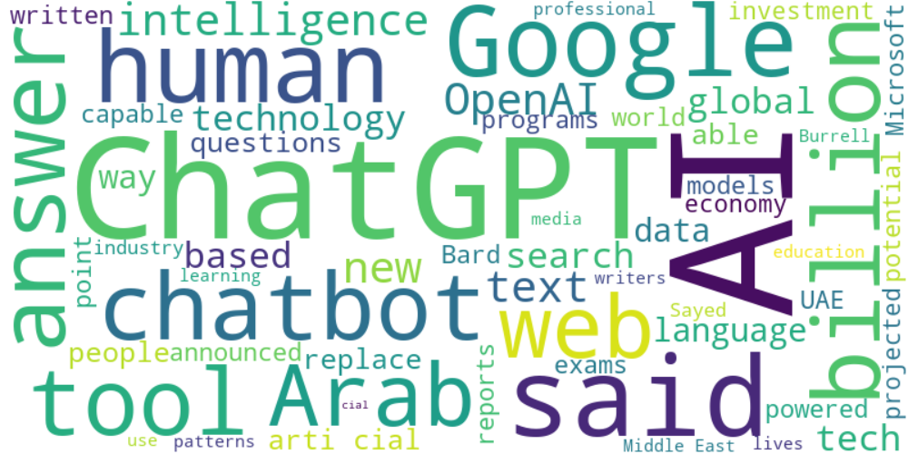

Top 10 words:

- AI: 27

- ChatGPT: 18

- said: 10

- human: 8

- Google: 8

- billion: 7

- Arab: 6

- web: 6

- intelligence: 6

- OpenAI: 6

### Wordcloud of summary

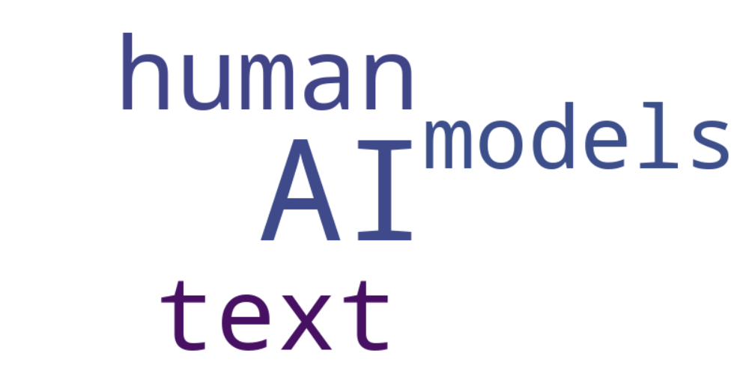

Top 10 words:

- AI: 9

- text: 4

- human: 4

- models: 3

- like: 3